UNIVERSITY OF LONDON INTERNATIONAL PROGRAMMES

BSc Computer Science and Related Subjects



CM3070 PROJECT
PRELIMINARY PROJECT REPORT

<Project title>

Author: Puriwat Puriyapan
Student Number : UOL 240662321 / SIM 10241944
Date of Submission:
Supervisor :

<NOTE that the overall maximum word count for the PPR is 6000 words excluding Appendices and References. If you follow strictly the maximum word count for each chapter, it will exceed 6000 words, i.e. you will need to decide which chapter(s) to trim to meet the overall word count limit>
Contents

CHAPTER 1: INTRODUCTION 3
CHAPTER 2: LITERATURE REVIEW 3
CHAPTER 3: PROJECT DESIGN 4
CHAPTER 4: FEATURE PROTOTYPE 5
CHAPTER 5: APPENDICES 5
CHAPTER 6: REFERENCES 5

INTRODUCTION
The problem / motivation:
Young adults nowadays between 18 and 30 years old want to start investing in stocks to make their own money. However, they are facing a real barrier to doing it well. Professional financial advice is expensive, and first-time investors lack both the funds to pay for an advisor and the financial literacy to interpret market data on their own. Instead, they rely on free stock apps, social media tips, and online forums — sources that either overwhelm them with jargon or hand them BUY and SELL signals with no reasoning behind them.

The problem is not lack of information about investing. It is a lack of understandable information at the moment a decision needs to be made. A new investor opening a typical stock app sees prices, charts, and sometimes a recommendation, but no explanation of why one stock looks promising to buy and another does not.

A free, easy-to-use tool that shows stock recommendations in plain English, with the reasoning made explicit, addresses this gap. By telling the user not only what to consider buying or selling but why, the system allows them to decide whether to trust each recommendation, learn something about investing each time they use it, disagree with the model when their own view differs, and feel in control of their money rather than outsourcing every decision.

(220 words)

Project Concept:
The project is to develop AI that lets users input the company they want to buy stock in, analyse price data by using historical data and returns a BUY/SELL recommendation with current price in plain English on a web interface. This system is designed for young adults between 18-30 years old who want to start investing in stock but can't afford professional advice. The system helps them have the first step of investing because this application will help to make an easier decision whether to buy or sell on a stock they are interested in. This addresses the gap identified above by explaining every recommendation in plain English and avoiding technical jargon.

The system works as follows. When a user enters a ticker on the web interface, the system fetches historical data. The system computes technical indicators from the price data. These indicators are then passed to a trained model Random Forest as a baseline and Long Short-Term Memory (LSTM) as the main model which predicts BUY or SELL. Next, SHAP values identify which indicators drove the prediction. These outputs are then translated into plain English and displayed
on the web interface alongside the recommendation and a chart.

In contrast, this project fills this gap by providing plain-English explanations so that users can understand the recommendation without needing to understand financial jargon. It also serves non-technical users by removing the need for coding skills and providing a web interface to display recommendation, the explanation, and a chart at no cost to the user.

(254 words)

Project Template:
The project template chosen for this project is Project Idea 4.2: Financial Advisor Bot, from the CM3020 Artificial Intelligence module. This project addresses the requirements of that brief by applying machine learning techniques for stock data, providing a web interface for non-technical users, explaining recommendations for young investors, and evaluating the system through backtesting.

(55 words)

Aim, Objectives, and Deliverables:
The goal of this project is to build a financial advisor bot through a web interface for young non-technical investors. This system displays recommendations and explanations in plain English.
(29 words)

Deliverable 1 Data pipeline:
The objective of the data pipeline is to fetch price data from yfinance. This provides information for any US stock in the form of daily historical price data. This data is then analysed by the ML models.

(37 words)

Deliverable 2 Technical indicators:
The objective of the technical indicators is to translate raw price data into features the model can learn patterns from. The deliverable is a module that calculates indicators such as MA, RSI, and MACD.

(34 words)

Deliverable 3 Machine learning models:
The objective of the machine learning models is to predict BUY/SELL from the technical indicators, using Random Forest as a baseline and LSTM as the main model. The deliverable is a trained RF model and a trained LSTM model which can be compared to evaluate whether LSTM adds value over the baseline.

(53 words)

Deliverable 4 Backtesting / evaluation:
The objective of backtesting is to evaluate how the trained models perform on data they have not seen during training. The deliverable is a backtesting module that applies walk-forward validation and compares model performance against a buy-and-hold baseline.

(38 words)

Deliverable 5 Explainability:
The objective of the explainability layer is to identify how much each technical indicator contributed to a given prediction. The deliverable is a SHAP analysis module and a plain-English generator that converts SHAP values into readable explanations.

(37 words)

Deliverable 6 Web interface:
The objective of the web interface is to make the system accessible to non-technical users. The deliverable is a website built using Flask, where the user enters a ticker and sees the recommendation, explanation, and chart.

Taken together, these six deliverables establish a working financial advisor bot that is able to give recommendations and explanations in plain English for young non-technical investors.

(62 words)

LITERATURE REVIEW

2.1 Introduction
Plainstock is an advisor bot that recommends, explains, and graphs stock advice in plain English for non-technical and new investors. It addresses problems with existing apps, which are expensive, show raw data without recommendations, or rely on human advisors whose advice can be emotional. This chapter covers four areas: existing stock apps and their limitations; machine learning methods for prediction (LSTM and Random Forest); technical indicators used as features; and explainable AI (SHAP) for plain-English explanations. The project aims to fill this gap by giving users a free tool that provides recommendations and explanations in plain English, with graphs displayed on a website.
(103 words)

2.2 Existing Apps and Their Limitations
Several existing tools try to help retail investors, but each has limitations that leave a gap for non-technical users and young investors. Robinhood is a commission-free trading app that lets users buy and sell stocks, ETFs, and other assets from their phone (Robinhood, 2026). It made investing more accessible, but it gives prices and charts without explaining whether a stock is a good choice or why. It has also been criticised for "gamifying" investing; it removed a confetti animation after accusations that its design encouraged risky trading among inexperienced users (Money, 2021). This shows the problem with a tool that gives results but no reasoning.
Bloomberg Terminal sits at the opposite end. It provides huge amounts of professional financial data and analysis, but it is extremely expensive around $31,980 per year for a single user in 2026 (Godel Discount, 2026) and uses heavy jargon and special commands that require training, so it is out of reach for an ordinary young investor. Open-source GitHub trading bots are free but require coding skills to set up, and their output is numbers rather than plain English, so they are not suitable for non-technical users. Human financial advisors give personalized advice, but it can be influenced by emotion or commission, is expensive and slow, and is not available on-demand for a single stock.
None of these tools provide a free, plain-English explanation of a recommendation for a single stock to a non-technical user and that is the gap Plainstock fills.
(247 words)

2.3 Machine Learning Methods for Stock Prediction
Random Forest (Breiman, 2001) is a supervised ensemble learning algorithm that builds numerous individual decision trees during training and outputs the mode of the classes (for classification) or the mean prediction (for regression). It was chosen as the baseline model because it improves on a naive model: rather than simply repeating the last price, it predicts whether a stock is likely to rise or fall by capturing complex, non-linear market relationships, and it handles mixed data types well.

LSTM (Long Short-Term Memory) is a neural network that is good at learning from sequential, time-ordered data (Hochreiter and Schmidhuber, 1997). It is suitable for this project because stock data is sequential. Each trading day produces a new set of values and LSTM can retain important information over long time periods. Fischer and Krauss (2018) applied LSTM to S&P 500 stocks from 1992 to 2015 to predict next-day direction, and it beat the other models they tested. However, the reported returns were strongest before transaction costs and before 2010, suggesting that the strategy's practical profitability may not persist in more recent markets.Similarly, Nelson et al. (2017) used LSTM with technical indicators and got better results than several conventional machine learning methods, which supports using indicators such as RSI and MACD as input features in this project. However, their evaluation was performed on a limited set of markets and historical datasets, so the findings may not generalise to all stocks, time periods, or market conditions.

In this project, the LSTM model achieved an accuracy of 0.552, beating Random Forest at 0.464, but neither model beat the majority baseline of 0.611. This is related to Fischer and Krauss (2018), who found that the benefit of LSTM prediction faded after 2010. My result continues this finding, showing that the predictive edge is hard to find in recent market data.
(309 words)

2.4 Technical Indicators as Features
Technical indicators are numbers calculated from past price and volume data that summarise how a stock has been behaving. Plainstock uses four main indicators as input features for its models. The Moving Average (MA) is the average price over the last N days; it smooths out daily noise and shows the trend, so when the current price is above the moving average the recent trend is upward. The Relative Strength Index (RSI), introduced by Wilder (1978), is a number between 0 and 100 that measures how fast and how much a price has risen or fallen; a value above 70 suggests the stock is overbought and below 30 suggests it is oversold, which captures momentum.

MACD (Moving Average Convergence Divergence), developed by Appel (2005), compares a short-term and a longer-term moving average, and when the short-term crosses above the long-term it can signal upward momentum starting. Bollinger Bands, created by Bollinger (2001), draw a band above and below the moving average based on volatility, showing when a price is unusually high or low compared to its recent average. These indicators are used as features instead of raw prices because they capture patterns trend, momentum, and volatility in a form the model can learn from more easily. Nelson et al. (2017) showed that feeding technical indicators into an LSTM produced better results than several conventional methods, supporting their use in this project.
(231 words)

2.5 Explainable AI (SHAP)
Machine learning models such as Random Forest and LSTM give a prediction to buy or sell, but they do not explain the reason, so a young investor cannot decide whether the recommendation should be trusted. SHAP (SHapley Additive exPlanations), introduced by Lundberg and Lee (2017), is a framework that assigns an importance score to each feature to explain an individual model prediction, quantifying the specific positive or negative contribution of each feature. Muhammad et al. (2024) applied SHAP to a deep learning model that classifies stock market patterns, using it to explain which features drove each prediction; their work shows SHAP can make a complex model's decisions interpretable and help solve the black-box problem. However, the study focuses on trend-pattern classification rather than realistic trading profitability, so high classification accuracy does not necessarily translate into profitable investment strategies. SHAP outputs are also technical values that a non-technical user cannot easily understand, and Plainstock fills this gap by translating SHAP feature contributions into plain-English explanations, so a young investor can read why a recommendation was made and judge whether to trust it.
(181 words)

2.6 Conclusion
The literature reviewed in this chapter supports both the motivation and the design of Plainstock. Existing tools each leave a gap: Robinhood gives recommendations without explanation, Bloomberg Terminal is expensive and full of jargon, open-source trading bots require coding skills, and human advisors are costly and not always objective. The machine learning literature (Fischer and Krauss, 2018; Nelson et al., 2017; Breiman, 2001) shows that LSTM and Random Forest can be applied to stock prediction, while also setting realistic expectations, a point confirmed by this project's own finding that neither model beat a simple baseline. The technical indicator literature (Wilder, 1978; Bollinger, 2001; Nelson et al., 2017) supports using indicators such as RSI, MACD, and Bollinger Bands as model features. Finally, the explainability literature (Lundberg and Lee, 2017; Muhammad et al., 2024) shows that SHAP can make model predictions interpretable. The key gap that no reviewed work fills is combining prediction, technical-indicator features, and SHAP explanations into a free tool that translates results into plain English for non-technical users. This is the gap Plainstock is designed to fill.
(178 words)

PROJECT DESIGN

3.1 Domain and Users
Plainstock is a data science and machine learning project, delivered as a web application, in the domain of retail investment technology (fintech). The project is aimed at non-technical, first-time investors, typically young adults aged 18 to 30, who want to invest but lack the financial knowledge or money to access professional tools. These users are not comfortable with command-line tools or open-source trading bots on Github, which require coding skills. They also struggle with apps that give a result without any reasoning. What they need is a simple tool that gives a clear recommendation and explains, in plain English, why a stock should be bought or sold, so they can understand and judge the advice themselves.
(116 words)

3.2 Justification of Design Choices
The system explains its recommendations in plain English rather than only showing a BUY or SELL result or raw technical numbers. This is because the target users are non-technical, and a plain-English explanation, together with a graph, helps them understand the reasoning behind a recommendation and decide for themselves whether to act on it.

The project is delivered as a web application to close the gap between technical and non-technical users. A website can be accessed easily without installing software or using a command line, which keeps it simple for non-technical users. It also conveniently displays the recommendation, the plain-English explanation, and a price graph together in one place.

The tool is free because the existing alternatives are expensive. A Bloomberg Terminal costs around $31,980 per year, and human financial advisors are also costly and may be influenced by emotion or commission. Making Plainstock free removes the cost barrier for young, first-time investors who cannot afford these options.
Two models were used so they could be compared against each other: Random Forest as a simple baseline, and LSTM as a more advanced model. The aim was to test which model performs better at analysing the technical indicators and predicting BUY or SELL, so the stronger one could be identified as the main model.
SHAP was included to explain which technical indicators pushed the model's decision. It assigns each feature a signed value positive means it pushed the model toward BUY, negative toward SELL. Importantly, SHAP does not make the prediction itself; it only explains why the model decided to buy or sell, adding a layer of transparency on top of the plain-English explanation.
(274 Words)

3.3 Overall Structure (Architecture)
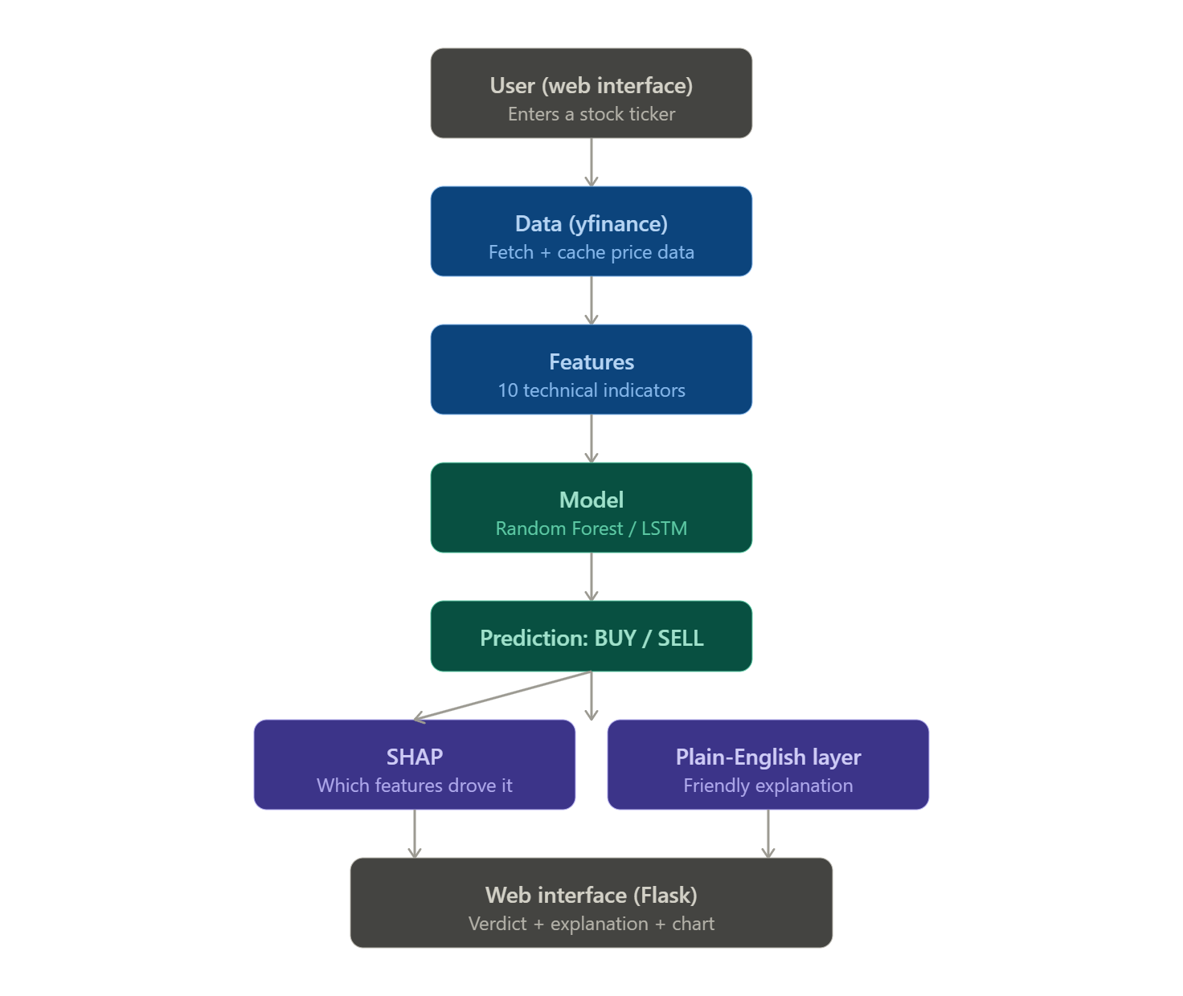
The architecture follows a pipeline, shown in Figure 1. When a user enters a stock ticker they are interested in on the web interface, the system receives the input and fetches price data from yfinance. From this data, the system computes the technical indicators. Both the Random Forest and LSTM models then take these indicators and predict BUY or SELL. SHAP explains which features pushed the model's decision, and the plain-English layer translates this into a recommendation and explanation the user can understand. Finally, the web interface displays the description, the recommendation, and a stock chart.
(96 words)

3.3 Technologies and Methods
Python was chosen as the main language because most machine learning libraries are written in Python, which makes it suitable for a project built around ML models. The remaining technologies were each chosen for a specific role in the pipeline.
yfinance provides free historical stock price data through a simple Python interface, which suits a free tool. pandas is used to handle and process the price data and to calculate the technical indicators; the indicators were calculated directly in pandas rather than using a pre-built library, which means the underlying maths is understood and was hand-verified during development. scikit-learn provides the Random Forest model and is a standard, well-documented machine learning library. TensorFlow/Keras is used to build the LSTM model, as it supports neural networks and sequential data. SHAP is used to explain which features drove the model's predictions.
Flask was used for the web application because it is a lightweight Python web framework. It is simple and well suited to a small project like this, without the extra complexity of a larger framework such as Django. Plotly was used to plot the stock price chart so the user can see how the price moved over time and easily understand whether it has been going up or down.
For development, Git was used for version control to track changes throughout the project, and pytest was used to write and run the unit tests that check each part of the system works correctly.
(243 words)

3.5 Work Plan

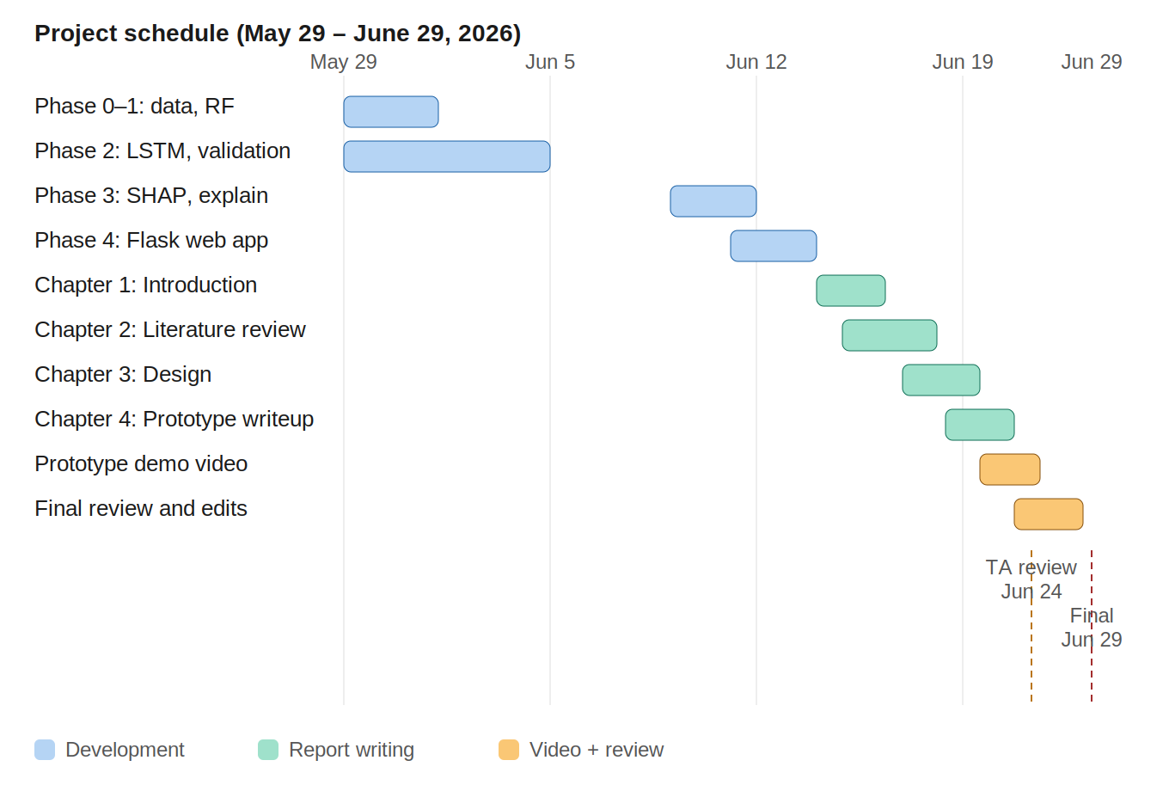

The project was developed in phases as shown in Figure 2. Phase 0 set up the project scaffold, and Phase 1 created the data fetcher, the first indicator the BUY/SELL target, Random Forest baseline. Phase 2 will start adding the full indicator set, walk-forward validation, and the LSTM model, followed by a fair comparison between the two models. Phase 3 added the plain-English explanation layer (the rule-based plain-English generator and SHAP). And Phase 4 built Flask web application and frontend. Each phase built on the previous one, so the pipeline grew in a logical order from data through to the web interface. After development was complete, the remaining tim was used to write a preliminary report and record demonstration video. The two key milestones are the TA review on 24 June and the final submission 29 June.
(138 words)

3.6 Test and Evaluation Plan
The project is tested and evaluated in two ways: software testing to confirm the code works correctly, and model evaluation to measure how good the predictions are.
For software testing, a large set of unit tests was written using pytest, covering each part of the system the indicators, the BUY/SELL target, the models, and the web layer — to make sure there are no bugs before a user uses the tool. The indicator calculations were hand-verified against worked examples, and leakage guards were built in (such as chronological train/test splits and fitting the scaler on the training data only) so that the model is never accidentally trained on future information.
For model evaluation, the key aim is to test whether the model beats a majority baseline, and whether the trading strategy beats a simple buy-and-hold approach. This is evaluated using walk-forward validation across multiple folds, comparing accuracy against the majority baseline, and running a backtest against buy-and-hold with transaction costs included. The backtest is measured using financial metrics such as total return, Sharpe ratio, and maximum drawdown.
(178 words)

FEATURE PROTOTYPE
<This is a new element of the submission, details below (1500 words). The feature prototype should be an implementation of at least one of the most important technical features used in the project to show that it is feasible.

It should work as designed, but it is OK at this stage if developing the prototype shows that the feature is not as effective as expected.

Students should describe the prototype in the final chapter of the PPR, together with an evaluation of how well you think the prototype works and how you would improve it. Students should also submit a 3-minute video demonstrating it.>

APPENDICES
<Appendices should be cross-referenced in the relevant section of the main text. No Appendix should be present unless cross-referenced from the main text. The Appendices should include any permission letters that give provenance for a work-based Project, or for access to specific organisations or materials. >

REFERENCES
<Giving full publication details of all literature referred to in the PPR. For details, please refer to: https://onlinelibrary.london.ac.uk/support/information-skills/organising-and-citing-your-references/citing-references. This list will generally be much shorter than that for the (later and much larger) Final Project Report.>

